Implementation of Elastic Beanstalk deployment through Jenkins CI/CD using AWSEB Deployment Plugin:

* Freestyle project
* Pipeline project

The basic IAM role (with restricted permissions to selected environments and resources) and policies is given in the embedded document below.

Steps to create credentials:

Go to Manage Jenkins -> Manage Credentials -> Click on ‘Jenkins’ under Stores scoped to Jenkins.

Click on ‘Global Credentials’ domain -> Click ‘Add Credentials’ found at the left.

* GitHub credentials:

Kind – Username with Password

Scope – System (Jenkins and nodes) or Global (Jenkins, nodes, items and child items etc). Choose appropriate scope.

Give an ID name to reference this credential in Jenkins configuration.

Fill in with required details.

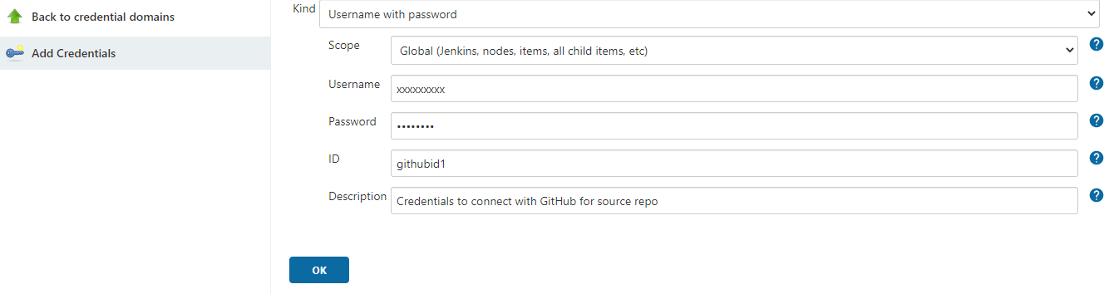

* AWS credentials for EB deployment:

Choose

Kind – AWS credentials

Scope – System (Jenkins and nodes) or Global (Jenkins, nodes, items and child items etc). Choose appropriate scope.

IAM role – Provide the complete ARN of the role.

Fill in with required details.

Inorder to make it more secure MFA can be used.

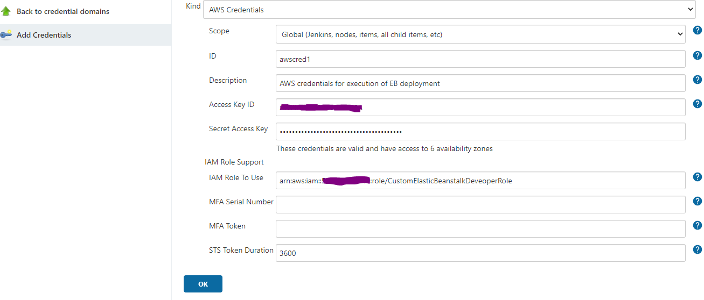

Freestyle project (Jenkins UI):

. Open Jenkins UI console.

. Click on ‘New Item’ in the left pane.

. Give appropriate Item name and choose ‘Freestyle project’.

. Click OK.

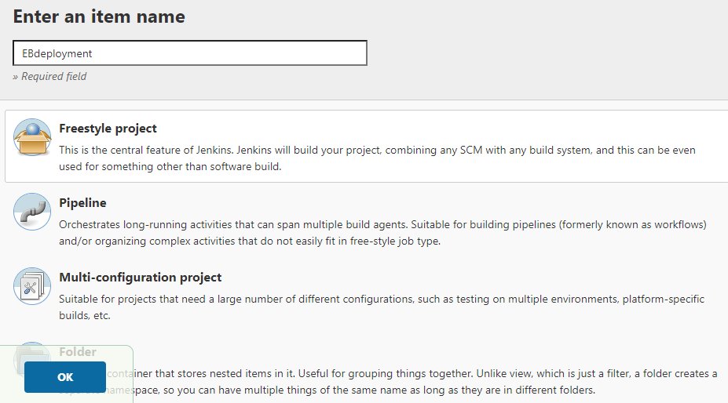

. Configuration page of this project will be opened.

. Provide Description.

. Under Source Code Management section: Choose Git. Provide GitHub repo URL, Choose the GitHub credentials added before, provide branch details.

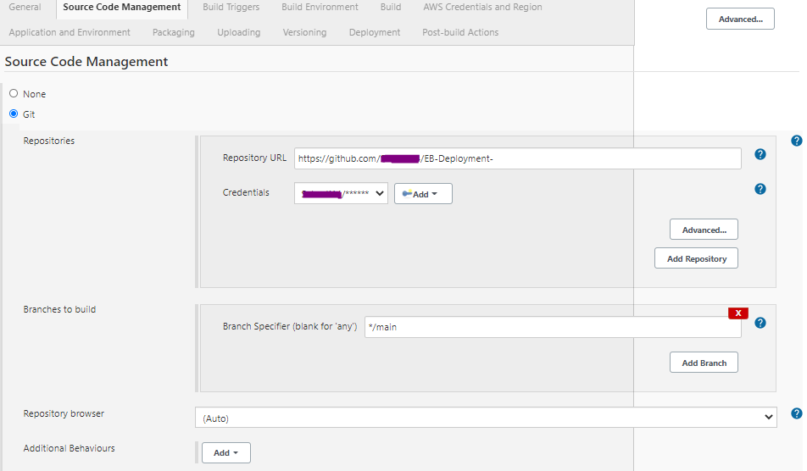

. Under Build section, Click on Dropdown Add build step and Choose AWS ElasticBeanstalk.

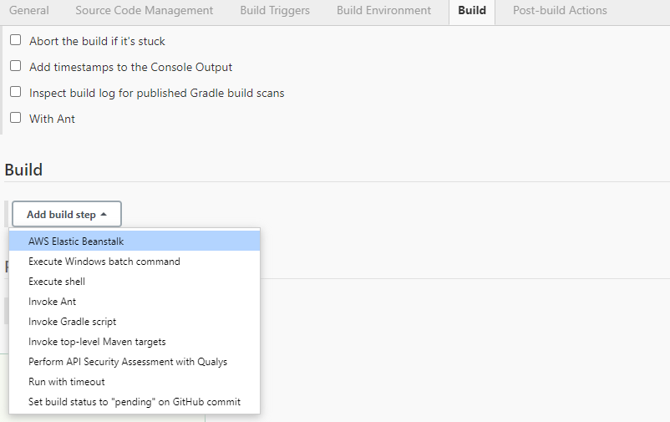

. AWS Elastic Beanstalk configuration tab opens. Provide the AWS configurations and beanstalk environment details.

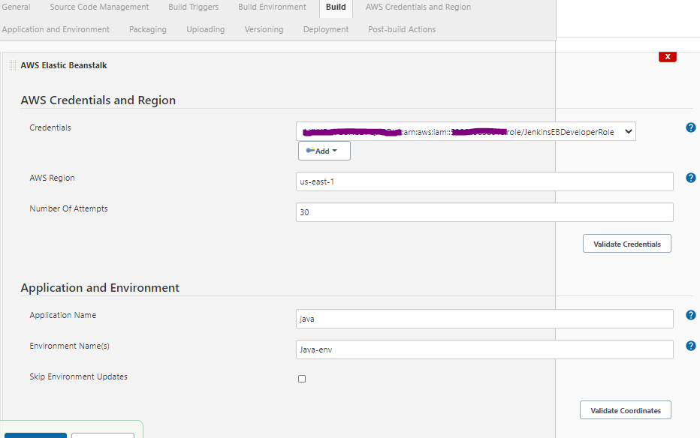

. Provide the source bundle details, S3 bucket details and application version details.

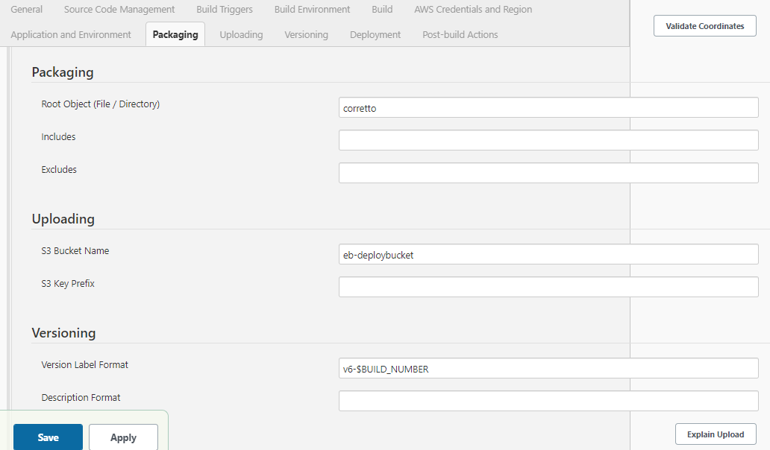

. Provide details of the deployment

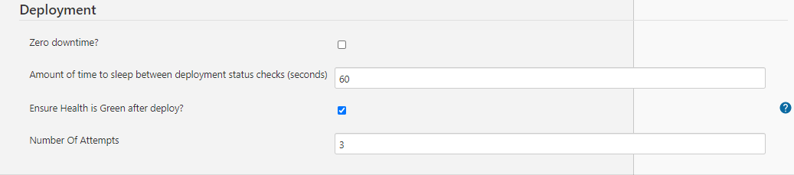

. Click ‘Save’.

Once Project is configured, you can click on Build Now option in the left pane to trigger the job.

We can set various other parameters for Git polling, Periodic or scheduled builds, Post build step actions like email notification etc. Configuration options can be explored and utilized further.

Sample console output:

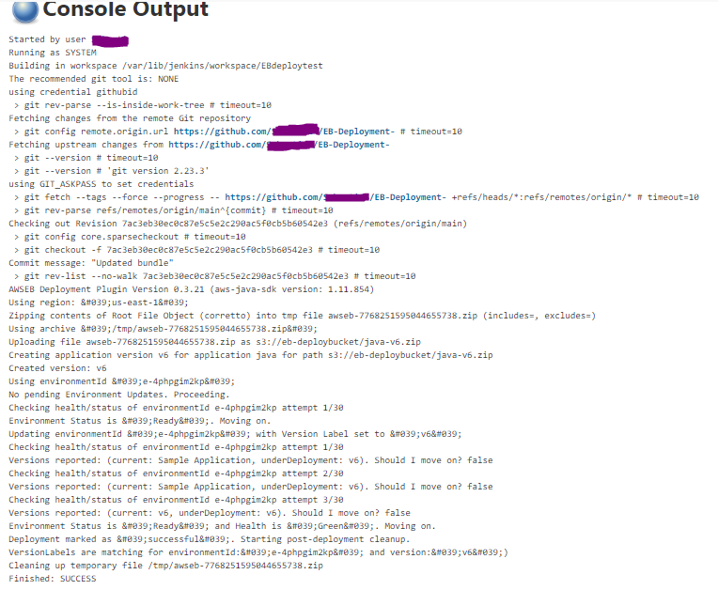

The same process can be followed for new pipeline configuration as Pipeline project.

Pipeline using script in SCM:

. Update the GitHub repository where the source bundle directory is created with a File named Jenkinsfile and the specs directory having eb_deploy_specs.yml file.

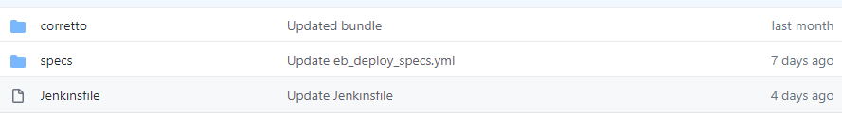

Contents of the Jenkinsfile and eb_deploy_specs.yml file is given in the Github link - .

. Go to Jenkins dashboard in the console.

. Click on New Item. Provide a name and choose Pipeline. Click OK.

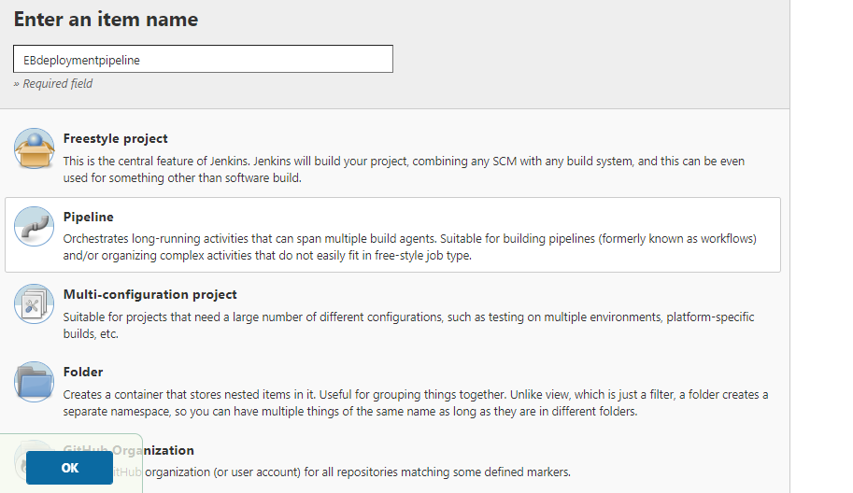

. Go to Pipeline section. Choose Definition as Pipeline script from SCM.

. Provide Git details. Save your configuration.

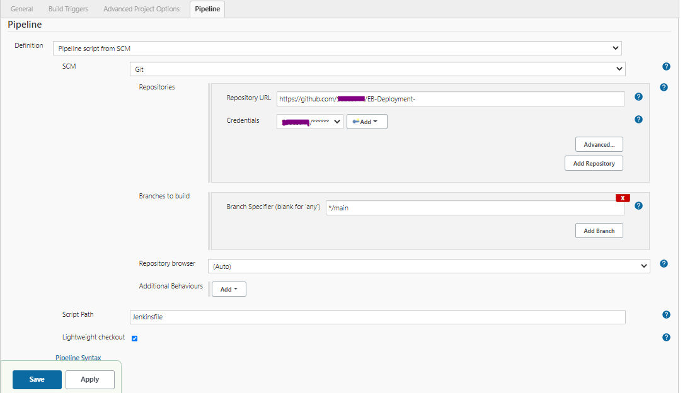

You can configure other build triggers, post build actions etc as required.